9.98: a) From Exercise 9.49, the rate of energy loss is 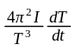; solving for the moment of inertia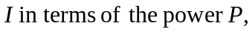

b) 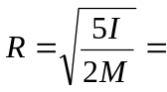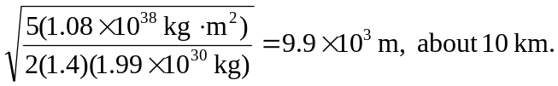

c) 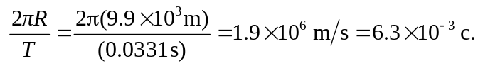

d) 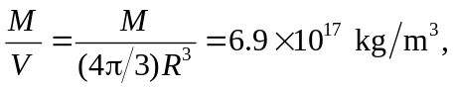

which is much higher than the density of ordinary rock by 14 orders of magnitude, and is comparable to nuclear mass densities.

